Use Case Realisation Report (Analysis) - Security Management
FOR
Volunteer Management System
(VMS)

CLIENT
PROJECT | Volunteer Management System (VMS)
TITLE | Use Case Realisation Report (Analysis) - Security Management
VERSION | 0.3a
DATE | 13-Aug-2011
 | ORIGINATOR
 | Name / Signature | Team 8S
 | APPROVAL
 | Name / Signature | Phung Kim Cuong, Dio
Institute of Systems Science |  | Document Reference
25 Heng Mui Keng Terrence  Singapore 119615 |  | VMS/T-1.4.1/1

 | Acceptance
 | Customer Signature |  | Customer Signature
 | Name & Designation |  | Name & Designation
 | Date & Company Stamp |  | Date & Company Stamp

Revision History

Date | Version | Description | Author
12-Jun-2011 | 0.1a | Creation | Team 8S
12-Aug-2011 | 0.2a | Updates | Team 8S
12-Aug-2011 | 0.3a | Updates | Team 8S

Table of Contents

1. Brief Description 3
2. Flow of Events 3
2.1 Standard Flow 3
2.1.1 Log-In 3
2.1.2 Change Password 4
2.1.3 Log-Out 5
2.1.4 Request for New Password 5
2.2 Exceptions 5
3. Interaction Diagrams 6
Collaboration Diagram for Login 6
3.1 6
Collaboration Diagram for Change Password 6
3.2 6
3.3 Collaboration Diagram for Logout 7
Collaboration Diagram for Request for New Password 7
3.4 7
4. Participating Objects 8
4.1 User 8
4.2 SecurityScreen 8
4.3 NAVMenu 8
4.4 HomeScreen 8
4.5 ExchangeServerIF 8
4.6 MainController 8
4.7 SecurityController 8
5. Class Diagram 9
6. Derived Requirements 9
ANNEX D Amendment History 10

Use Case Realisation Report (Analysis) - Security Management

Brief Description
The use case describes the security management of VMS system. Registered user can login/logout of the system. Meanwhile, User is able to make changes to password after login. And registered User can also request for a new password when he/she forgets the old password.

Flow of Events
The standard flow of events for this use case and any exceptions are described in the following subsections. See section 3 for an overview of the participating Actors and Domain Objects.

Standard Flow
This use case provides the user interface related functionality that will be provided to the User, as follows:

Log-In
To commence using the system functions, the User is required to login as follows:
- When the Anonymous User clicks ‘Login’ link on the NAVMenu, the NAVMenu.login() is triggered and it will trigger MainController.redirectURL() method to redirect the system to SecurityScreen.
- MainController.redirectURL() will use SecurityScreen.show() to display an authentication form to enable user to input registered username and password.
- Anonymous User enters the email address and password on the screen
- When Anonymous User click ‘submit’ button, the SecurityScreen.onSubmit() method is triggered and it will use SecurityScreen.validFormat() method to perform format checking.
- After format checking, SecurityController.validUserPassword() is triggered to do username and password authentication
- SecurityController.validUserPassword() will first use method User.getAllUsers() method to fetch all the Registered User Objects and compare the received username with these objects . If the recived UserName cannot be found, SecurityController.validUserPassword() will use SecurityScreen .displayMsg() operation to instruct the SecurityScreen to display ‘The username has not been registered’
- If username already exists in the database, , SecurityController.validUserPassword() will use User.validatePassword() method to compare the received password and the password stored in the object, and return a response to , SecurityController.validUserPassword() informing whether the password is valid or not
- If the password id valid, SecurityController.validUserPassword() will use SecurityScreen.displayMsg() to display ‘Successful login’
- If the password is invalid, SecurityController.validUserPassword() will use SecurityScreen.displayMsg() operation to instruct the SecurityScreen to display ‘Invalid password’.
- Upon a successful login, SecurityController.validUserPassword() will trigger HomeScreen.show() to redirect the system to HomeScreen.
- The use case terminates.

Change Password
If the User logs in successfully, he/she will be able to update his/her password as follows:
- When the User clicks ‘Change password’ on the NAVMenu, NAVMenu.changePassword() is triggered.
- NAVMenu.ChangePassword() will trigger MainController.redirectURL() to redirect current screen to SecurityScreen.
- After SecurityScreen.show() is triggered, the authentication form will be displayed to enable user to enter old password and new password.
- User will enter the old password and new password. When the user click ‘Change Password’ button, SecurityScreen.onSubmit() is triggered and it will perform the format validation of new password.
- If the format is not valid, SecurityScreen.displayMsg() will be triggered to display ‘Invalid format.’
- Upon the successful validation, the SecurityController.changePassword() will be triggered and it will call the User.getUserbyUserName() method to get the User Object.
- The SecurityController.changePassword() will use the User.validatePassword()to compare the received password with the one in the object.
- If the password is invalid, the SecurityController.changePassword() will use SecurityScreen.displayMsg() to display ‘Incorrect old password.’
- If the old password is valid, the SecurityController.changePassword() will use the method User.setPassword() to set the new password.
- After setting the new password, the SecurityController.changePassword() will use the method SecurityScreen.displayMsg() to display ‘Password has been changed successfully.’
- SecurityController. changePassword () will trigger HomeScreen.show() to redirect the system to HomeScreen.
- The use case terminates.

Log-Out
- When the User clicks ‘Log Out’ link on the NAVMenu, NAVMenu.logOut() is triggered and it will trigger MainController.logOut() method
- MainController.logOut() will use SecurityController.logout() to clear the user information
- SecurityController.logout() will clear the current session information of the user.
- Upon the successful logout, SecurityController.logout() will use HomeScreen.show() to redirect the system to the home screen.
- The use case terminates.

Request for New Password
- When the User clicks ‘Request for New Password’ link on the NAVMenu, NAVMenu .requestPassword() is triggered and it will use MainController.redirectURL() to redirect current screen to SecurityScreen.
- MainController.redirectURL() will use SecurityScreen.show() to display the SecurityScreen.
- The input form will be displayed to enable user to enter the username.
- User will enter the username.
- When user click ‘Submit’ button, the SecurityScreen.onSubmit() is triggered and it will use the SecurityController.requestPassword() to get Password.
- The SecurityController.requestPassword() will verify if the user has already registered or not. If not, SecurityController.requestPassword() will use the method SecurityScreen.displayMsg() to display ‘User Name does not exist in the system’.
- If yes, the MailServer.sendEmail() is triggered and new password will be sent to the user by email.
- The SecurityController.requestPassword() verifies if the user has already registered or not. If not, SecurityController will use the method SecurityScreen.displayMsg() to display ‘User Name does not exist in the system.’
- SecurityController. requestPassword () will use HomeScreen.show() to redirect the system to the home screen
- The use case terminates.

Exceptions
The following exceptions have been identified:
- Invalid Password. If User still failed to enter the correct password after ten attempts. The user account will be locked.
- Invalid New Password. If the new password is not conforming to the security format, system will prompt the format tips to assist users.
- Invalid email address. If the email address is not registered, system will display an error message.

Interaction Diagrams

Collaboration Diagram for Login
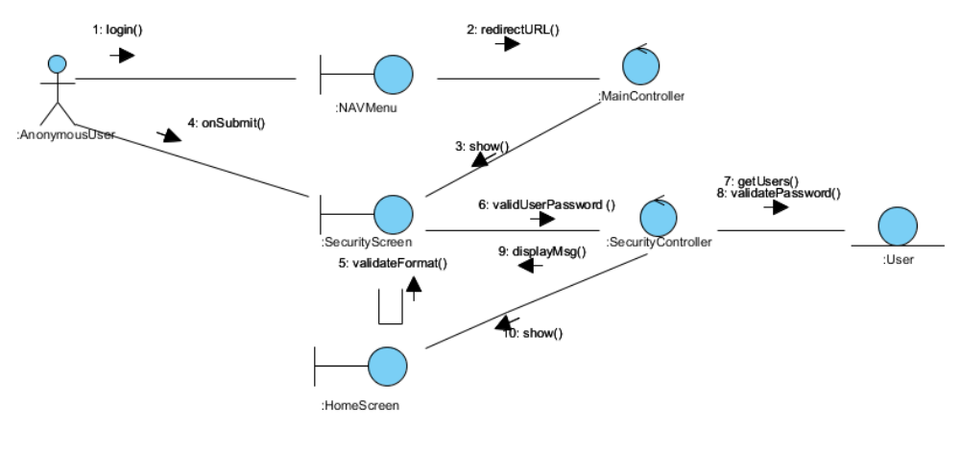
Figure 1 – Collaboration Diagram for Login

Collaboration Diagram for Change Password
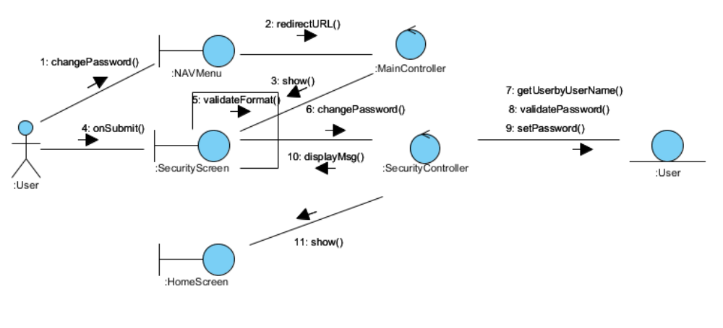
Figure 2 – Collaboration Diagram for Change Password

Collaboration Diagram for Logout
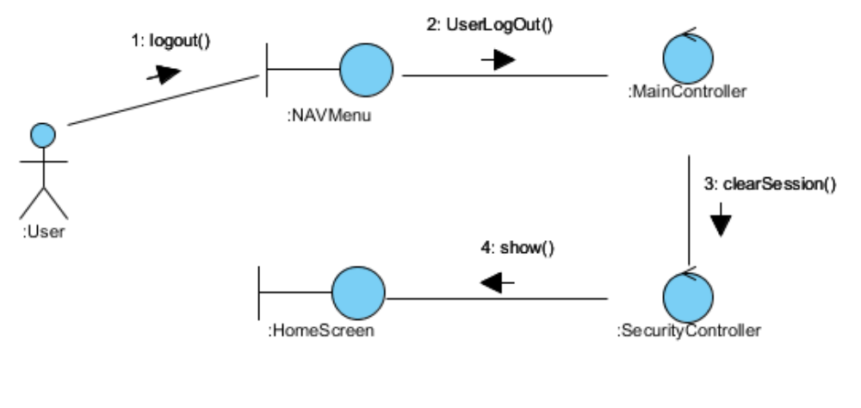
Figure 3 – Collaboration Diagram for Logout

Collaboration Diagram for Request for New Password
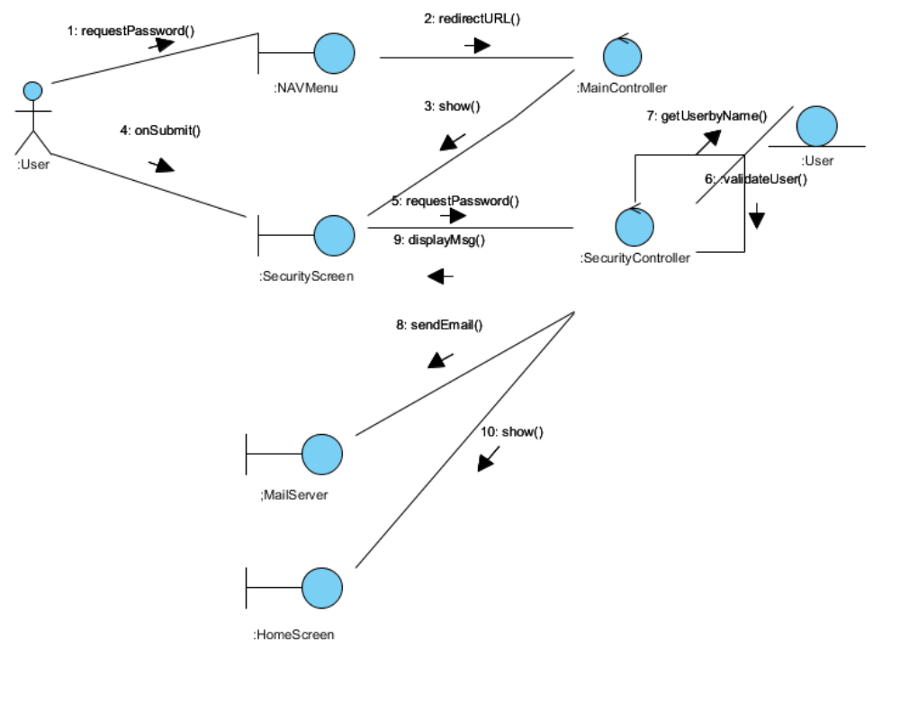
Figure 4 – Collaboration Diagram for Request for New Password

Participating Objects

Anonymous User Actor
This Actor represents the general public that intends to register a new volunteer account in the VMS system

User Actor
This Actor represents a registered user

User
This entity object stores the details concerning a user of the volunteer organisation. The primary attribute that it holds is the userID.

SecurityScreen
This boundary object is used to display security form and exchange security information with controllers.

NAVMenu
This boundary object is used to display system navigation map for user account related operations.

HomeScreen
This boundary object is used for redirecting and displaying of home screen details and menu. All the user actors use this object.

MailServer
This boundary object is used to interact with Mail Server and provide email service interfaces.

MainController
This control object co-ordinates the menu selection and dispatches of requests of the volunteer management system. It delegates the user requests to the specific use case control objects for carrying out the use cases.

SecurityController
This control object co-ordinates the authentication, retrieval and update of security information.

Class Diagram
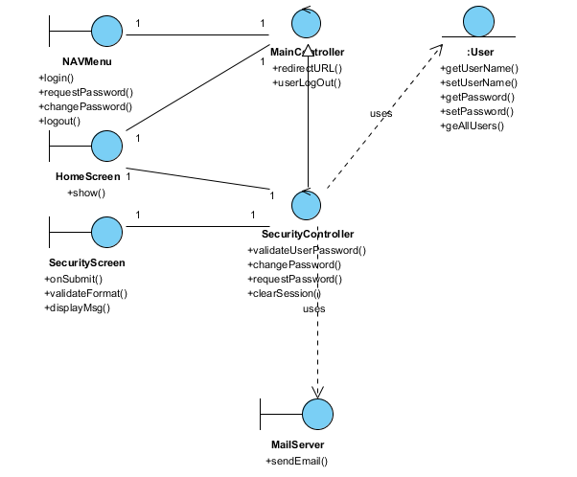
Figure 5 – Class Diagram

Derived Requirements
The User office PC (client system), keyboard and mouse will be used to process the project details and view all the system responses.

ANNEX D Amendment History

This is a record of all amendments made to the Document.
Version | Chapter / Section | Page No | Notes of Amendments or Changes

